Work plan

Deadlines
- 2020-02-24 Choose a project proposal and send your choice via email to epsatisep@gmail.com
- 2020-03-05 Define the Project Backlog (what must be done and key deliverables - every member should preferably participate in every task), Global Sprint Plan, Initial Sprint Plan (which tasks should be included, who does what) and Release Gantt Chart of the project and insert them on the wiki (planning)
- 2020-03-10 Upload the “black box” System Diagrams & Structural Drafts to the wiki
- 2020-03-27 Upload the detailed System Schematics, Structural Drawings & 3D Modelation to the wiki and do the cardboard scale model of the structure
- 2020-04-01 Upload the List of Materials (what & quantity) to the wiki
- 2020-04-08 Upload the Interim Report and Presentation to the wiki. The report must contain the the following chapters: Introduction, Project Management, State of the Art, Marketing Plan, Eco-efficiency Measures for Sustainability, Ethical and Deontological Concerns, Proposed Solution and Bibliography. In particular, the Project Management chapter includes the updated project progress register, the sprint report for completed sprints (tasks that were included, statuses, assignees, allocations) and the updated release Gantt chart
- 2020-04-16 Interim Presentation, Discussion and Peer, Teacher and Supervisor Feedbacks
- 2020-04-23 Upload the List of Materials (provider, price, quantity, including VAT and transportation) to the wiki
- 2020-04-30 Upload the Final video of the 3D Model to the wiki
- 2020-05-06 Upload Refined Interim Report (based on Teacher & Supervisor Feedbacks) to the wiki
- 2020-05-13 Upload Packaging solution to the wiki
- 2020-06-02 Upload the results of the (Prototype or Simulation) Functional Tests to the wiki
- 2020-06-12 Upload the Final Report, Presentation, Video, Paper, Poster and Manual to the wiki
- 2020-06-16 Final Presentation, Individual Discussion and Assessment
- 2020-06-22:
  - Update the wiki, report, paper with all suggested corrections
  - Upload to the OneDrive folders shared by epsatisep:
    - Deliverables (pdf and others)
    - Code (Arduino code, Tinkercad/CoppeliaSim simulation code, mobile and Web app code)
    - CAD (drawings and 3D model files)
    - Videos (3D model simulation and final team video in mp4)
- 2020-06-23:
  - Play final video
  - Play music/landscapes of your country
  - Receive the EPS@ISEP certificate

Project Plan
Define your optimal sprint duration and plan your sprints until project end using Global Sprint Plan Table .
Global Sprint Plan
Sprint | Start | Finish
Project | 03-20-2020 | 06-23-2020
First research | 02-20-2020 | 05-03-2020
System schematics and structural drafts | 03-06-2020 | 03-10-2020
System schematics and structural drawings, cardboard scale model | 03-11-2020 | 03-20-2020
List of materials completed | 03-21-2020 | 04-22-2020
Refined interim report | 03-26-2020 | 05-29-2020
Functional tests | 04-23-2020 | 06-12-2020
Upload of the final report, presentation, video | 06-03-2020 | 06-12-2020

Build your project backlog, including all relevant tasks/deliverables, using Project Backlog Table . Prioritize all backlog items (PBI), keeping higher priority items at the top, and lower priority at the bottom.
Project Backlog
PBI | Title | Status
Z | Drafts and structural drawings | In progress
K | List of materials | In progress
D | Create a name and a logo | In progress
A | State of the art | Almost done
B | Uploading Gantt Chart | In progress
E | Interim Report | To do
F | Design | To do
G | Functional Tests | To do
H | Final report | To do
I | Presentation | To do

Plan each sprint at its beginning (Sprint Planning session) using the Sprint Plan Table .
Sprint Plan
Sprint | Task | Duration (d) | Responsible | Involved
1 | D State of the Art | 2
1 | Z Global sprint plan | 1 |  | Team
1 | Z Project Backlog | 1 |  | Team
1 | Z Gantt Chart | 1 |  | Team
1 | Z Global sprint plan | 1 |  | Team
1 | K Defining a clear idea | 4 |  | Team

Review each sprint at its end and update each item status on the Progress Register Table .
Project Progress Register
Sprint | PBI | Responsible | Involved | Status
1 | Z | X and Y | X, Y, Z, W | Done
2 | K | Z | X, Y, Z, W | Done
3 | D | W, Y and Z | X, Y, Z, W | Done
4 | A | Y | X, Y, Z, W | Done
5 | B | Z and W | X, Y, Z, W | In progress
6 | E | X and W | X, Y, Z, W | In progress
7 | C | Y and Z | X, Y, Z, W | In progress

Current version of Gantt Chart. Gantt Chart was mainly made by using known deadlines. Figure . shows the construction of the Gantt Chart.
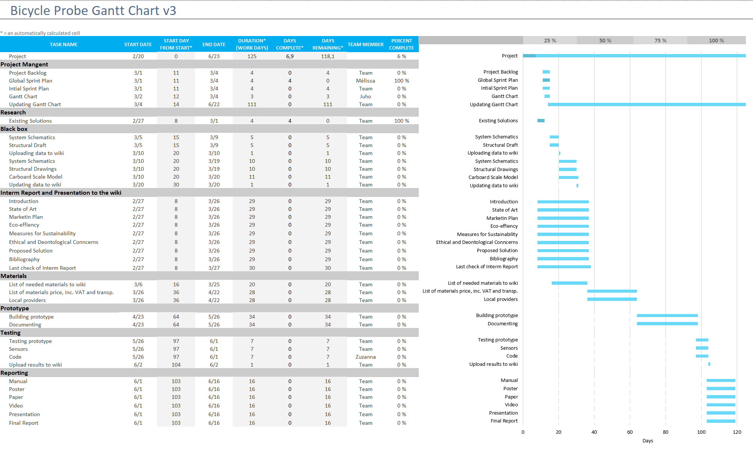
Gantt chart

